**DBMS PROJECT REPORT**

**ONLINE INVENTORY MANAGEMENT SYSTEM**

**Key Milestone 04**



## CSE403L Database Management System Lab

Group members

Arsalan khan (22PWCSE2110)

Waseem (22PWCSE2179)

Adnan Zeb (22PWCSE2191)

Class Section: A

“On my honor, as student of University of Engineering and Technology, I have neither given nor received unauthorized assistance on this academic work.”

Student Signature:

Submitted to:

## Engr.Sumayyea Salahuddin

(JULY 08, 2025)

Department of Computer Systems Engineering

University of Engineering and Technology, Peshawar

**Project Title**

Online Inventory Management System using Laravel 12 and MySQL

**Abstract**

This project is a web-based inventory and order management system built with Laravel 12 (PHP framework) and MySQL. It allows users to manage products, suppliers, customers, purchases, and sales orders with real-time stock updates and user-based access. The system helps small and medium businesses maintain clear records, generate reports, and ensure data integrity.

**Introduction**

Managing inventory and sales manually can be time-consuming and error-prone. This system aims to automate those tasks using a modern PHP framework (Laravel) and a relational database (MySQL). With responsive design and user-friendly interfaces, the application supports streamlined business operations.

**Objectives**

* To automate inventory tracking
* To manage suppliers and customers efficiently
* To enable real-time stock updates
* To generate purchase and order reports
* To deploy a secure, scalable web system

**Modules**

* User Authentication (Login/Register)
* Supplier Management
* Customer Management
* Product Management (with Categories & Units)
* Purchases and Purchase Details
* Orders and Order Details
* Stock Updates
* Payment Tracking (paid, due)
* Admin Dashboard with Charts

**Tools and Technologies**

* Laravel 12 – PHP web framework
* PHP 8.3 – Server-side language (used on InfinityFree)
* MySQL – Relational database
* XAMPP / Laragon – Local development server
* GitHub – Version control
* InfinityFree – Free hosting with PHP 8.3 support

**Project Benefits**

* Centralized inventory and sales tracking
* Automatic stock updates on purchases and sales
* Reduced risk of overstocking or running out of stock
* Faster customer order processing
* Transparent reporting and accountability
* Easy to maintain and extend

**Security Features**

* Laravel’s built-in CSRF protection
* Hashed passwords using Bcrypt
* Authenticated routes
* Form validation for all input fields

**Challenges Faced**

* Handling many-to-many relationships with pivot tables (e.g., order_details)
* Real-time stock updates during simultaneous orders
* Deployment limitations with shared/free hosting (e.g., InfinityFree’s file limits)

**Real-World Use Case**

Consider a retail store with multiple products and frequent purchase and sales transactions. Using this system, the store owner can easily:

* Add or update product details
* Track which supplier delivered which product and when
* Generate invoices and receipts for customer orders
* Monitor daily stock movement without relying on manual registers or Excel

**System Architecture**

The application follows the MVC (Model-View-Controller) architecture:

* **Model:** Handles data logic and communicates with the MySQL database
* **View:** Blade templates render dynamic HTML pages
* **Controller:** Manages user requests and responses

**Scalability and Maintenance**

Laravel’s modular structure and use of Composer packages make the system highly scalable. As the business grows, features like multi-user roles, warehouse management, or product barcodes can be added with minimal code changes.

**Data Accuracy**

One of the key goals of this system is to ensure that the inventory is always accurate. All stock increases or decreases are logged through purchases and orders, minimizing manual errors and providing a clear audit trail.

**Who Can Use This System**

* Small businesses (retailers, wholesalers)
* Inventory-based startups
* Schools/colleges managing store inventory
* Office supply departments
* Freelance developers as a base project

**System Modules**

* User Authentication
* Product Management
* Supplier and Customer Management
* Purchase Module
* Sales and Orders Module
* Stock Control
* Reports and Analytics Dashboard

**Entity Analysis Table**

| **Entity Name** | **Purpose** | **Key Attributes** | **Relationships** |
| --- | --- | --- | --- |
| **Users** | Manages the system | id, name, email, username, password | One-to-many with Purchases (created_by, updated_by) |
| **Suppliers** | Source of purchased products | id, name, email, phone, shopname, bank details | One-to-many with Purchases |
| **Customers** | Places orders | id, name, email, phone, address | One-to-many with Orders |
| **Categories** | Groups products | id, category_name | One-to-many with Products |
| **Units** | Defines measurement units | id, unit_name | One-to-many with Products |
| **Products** | Inventory items | id, name, code, buying_price, selling_price, stock | Belongs to Category & Unit; Many-to-many with Orders & Purchases |
| **Purchases** | Records supplier purchases | id, purchase_no, purchase_date, supplier_id | Many Purchase_Details; Linked to Supplier & User |
| **Purchase_Details** | Line items for purchases | purchase_id, product_id, quantity, unitcost, total | Links Purchases and Products (composite key) |
| **Orders** | Records customer orders | id, customer_id, order_date, total, payment_type | Many Order_Details; Linked to Customers |
| **Order_Details** | Line items for orders | order_id, product_id, quantity, unitcost, total | Links Orders and Products (composite key) |

**Entity Explanation with Attributes and Relationships**

### **1. Users**

* **Purpose:** System administrators or staff who log in and manage the system.
* **Attributes:** id, name, email, username, password, photo
* **Relationships:** One-to-many with purchases (created_by, updated_by)

**2. Suppliers**

* **Purpose:** External vendors from whom products are purchased.
* **Attributes:** id, name, email, phone, address, shopname, bank details
* **Relationships:** One-to-many with purchases

**3. Customers**

* **Purpose:** Buyers who place orders in the system.
* **Attributes:** id, name, email, phone, address, payment details
* **Relationships:** One-to-many with orders

**4. Categories**

* **Purpose:** Logical grouping of products.
* **Attributes:** id, category_name
* **Relationships:** One-to-many with products

**5. Units**

* **Purpose:** Measurement units for products (e.g., kg, pcs).
* **Attributes:** id, unit_name
* **Relationships:** One-to-many with products

**6. Products**

* **Purpose:** Items available for purchase and sale.
* **Attributes:** id, name, code, buying price, selling price, stock, image
* **Relationships:**
  + Belongs to a category
  + Belongs to a unit
  + Many-to-many with purchases (via purchase_details)
  + Many-to-many with orders (via order_details)

**7. Purchases**

* **Purpose:** Records of products bought from suppliers.
* **Attributes:** id, purchase_no, purchase_date, status, supplier_id
* **Relationships:**
  + Many purchase_details
  + Linked to suppliers and users

**8. Purchase_Details**

* **Purpose:** Line items for each purchase.
* **Attributes:** purchase_id, product_id, quantity, unitcost, total
* **Relationships:**
  + Composite key
  + Connects purchases and products

**9. Orders**

* **Purpose:** Sales made to customers.
* **Attributes:** id, order_date, total, status, customer_id, invoice_no, payment_type
* **Relationships:**
  + Many order_details
  + Linked to customers

**10. Order_Details**

* **Purpose:** Line items for each order.
* **Attributes:** order_id, product_id, quantity, unitcost, total
* **Relationships:**
  + Composite key
  + Connects orders and products

**Entity Relationship Diagram (ERD)**

#### **1. users**

* id (PK)
* name
* email
* username
* photo
* password

**2. suppliers**

* id (PK)
* name
* email
* phone
* address
* shopname
* type
* bank_name
* account_holder
* account_number
* photo

**3. customers**

* id (PK)
* name
* email
* phone
* address
* type
* bank_name
* account_holder
* account_number
* photo

**4. categories**

* id (PK)
* category_name

**5. units**

* id (PK)
* unit_name

**6. products**

* id (PK)
* product_name
* product_code
* buying_price
* selling_price
* stock
* product_image
* category_id (FK) → categories.id
* unit_id (FK) → units.id

**7. purchases**

* id (PK)
* purchase_date
* purchase_no
* purchase_status
* supplier_id (FK) → suppliers.id
* created_by (FK) → users.id
* updated_by (FK) → users.id

**8. purchase_details**

* purchase_id (FK, PK) → purchases.id
* product_id (FK, PK) → products.id
* quantity
* unitcost
* total

**9. orders**

* id (PK)
* order_date
* order_status
* total_products
* sub_total
* vat
* total
* invoice_no
* payment_type
* pay_int
* due_int
* customer_id (FK) → customers.id

**10. order_details**

* order_id (FK, PK) → orders.id
* product_id (FK, PK) → products.id
* quantity
* unitcost
* total

**Relationships**

* **One-to-Many:**
  + users → purchases
  + suppliers → purchases
  + customers → orders
  + orders → order_details
  + purchases → purchase_details
  + products → purchase_details / order_details
  + categories → products
  + 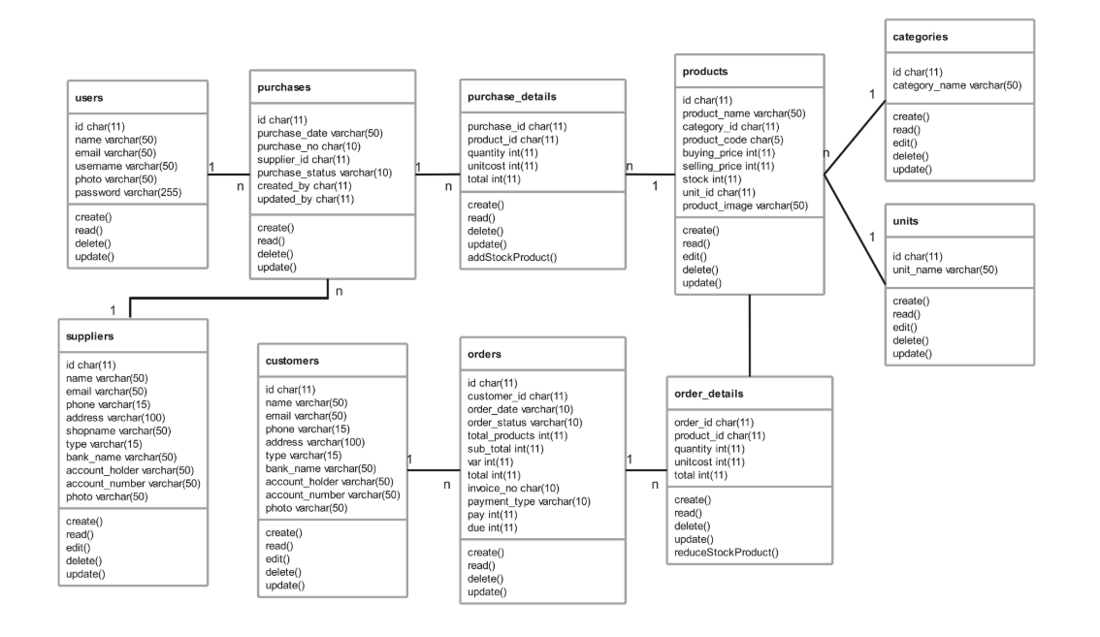units → products

**Enhanced Entity Relationship Diagram (EERD)**

The Enhanced Entity Relationship Diagram (EERD) expands on the basic ERD by adding more advanced modeling features such as specialization, generalization, and more detailed relationships. It is used to better represent real-world scenarios in complex systems like inventory management.

In this project:

* **Customers** and **Suppliers** are generalized as **Persons**, since both share common attributes (e.g., name, email, phone).
* **Products** are associated with both **Categories** and **Units**, showing classification and measurement relationships.
* **Purchases** and **Orders** are transactional entities connecting **Users**, **Suppliers**, **Customers**, and **Products**.
* **Purchase_Details** and **Order_Details** are used to handle many-to-many relationships with quantities and prices.

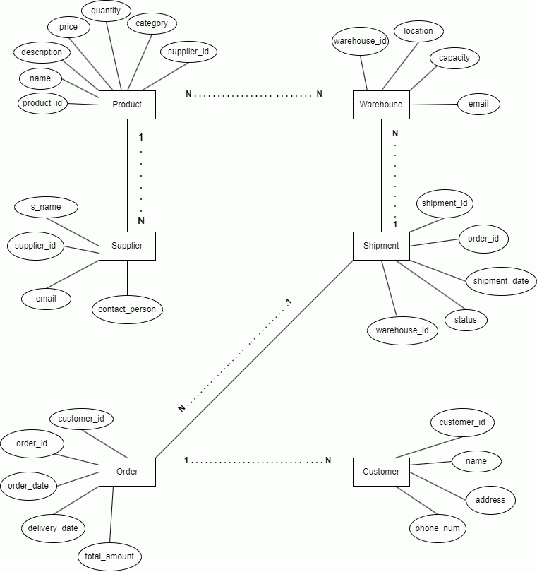

**Laravel Development Process**

**1: Setup Project**

composer create-project laravel/laravel inventory-system

cd inventory-system

php artisan serve

**2: Configure .env**

DB_DATABASE=inventory_db

DB_USERNAME=root

DB_PASSWORD=

**3: Create Models and Migrations**

php artisan make:model Product -m

php artisan make:model Supplier -m

php artisan make:model Order -m

**4: Run Migrations**

php artisan migrate

**5: Create Controllers**

php artisan make:controller ProductController

php artisan make:controller SupplierController

**6: Blade Templates & Routes**

* Views stored in /resources/views
* Routes defined in routes/web.php

**7: Authentication**

composer require laravel/ui

php artisan ui bootstrap --auth

npm install && npm run dev

**Implementation Details**

The system was built using **Laravel 8** and **MySQL**. Laravel's MVC structure was used to organize models, controllers, and views. All modules (products, orders, purchases, users) include full CRUD functionality using Eloquent ORM. Authentication is handled with Laravel UI.

The project was deployed on **InfinityFree** using **PHP 8.3**, and the database was imported via phpMyAdmin.

**LARAVEL MVC IMPLEMENTATION**

**MODEL LAYER**

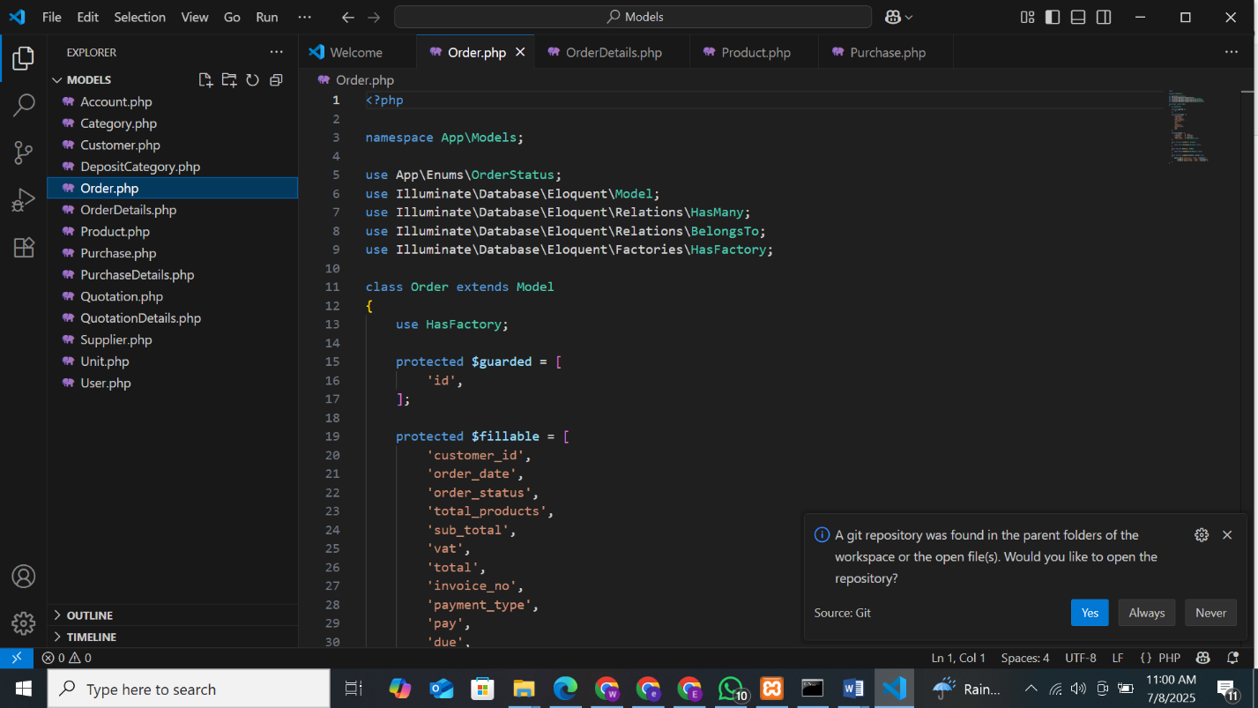

**CONTROLLER LAYER**

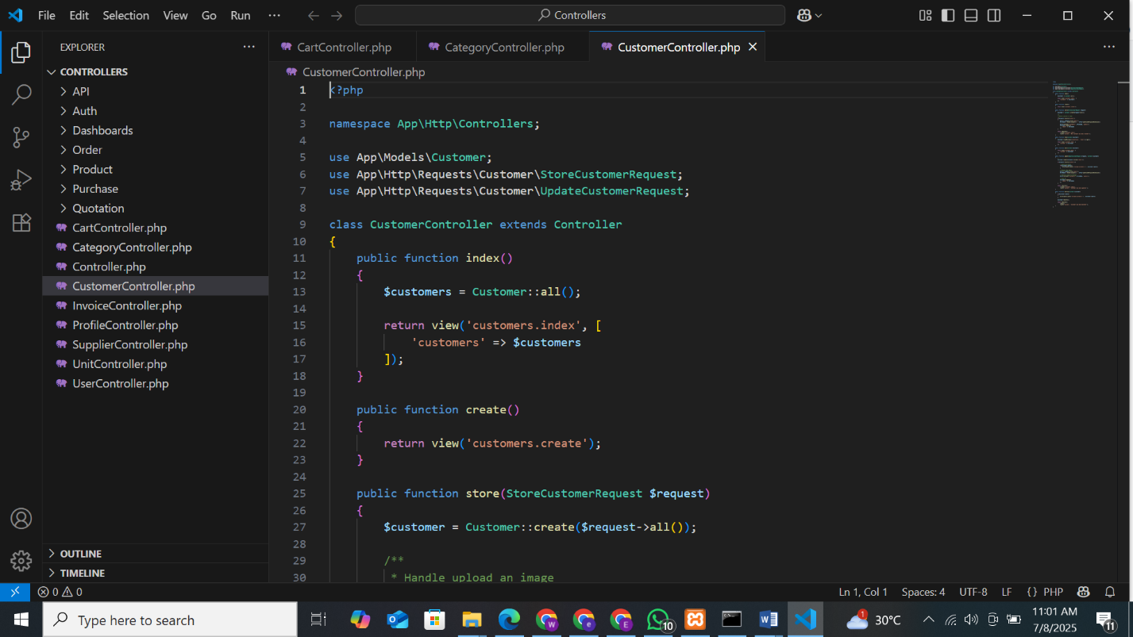

**LIVEWIRE**

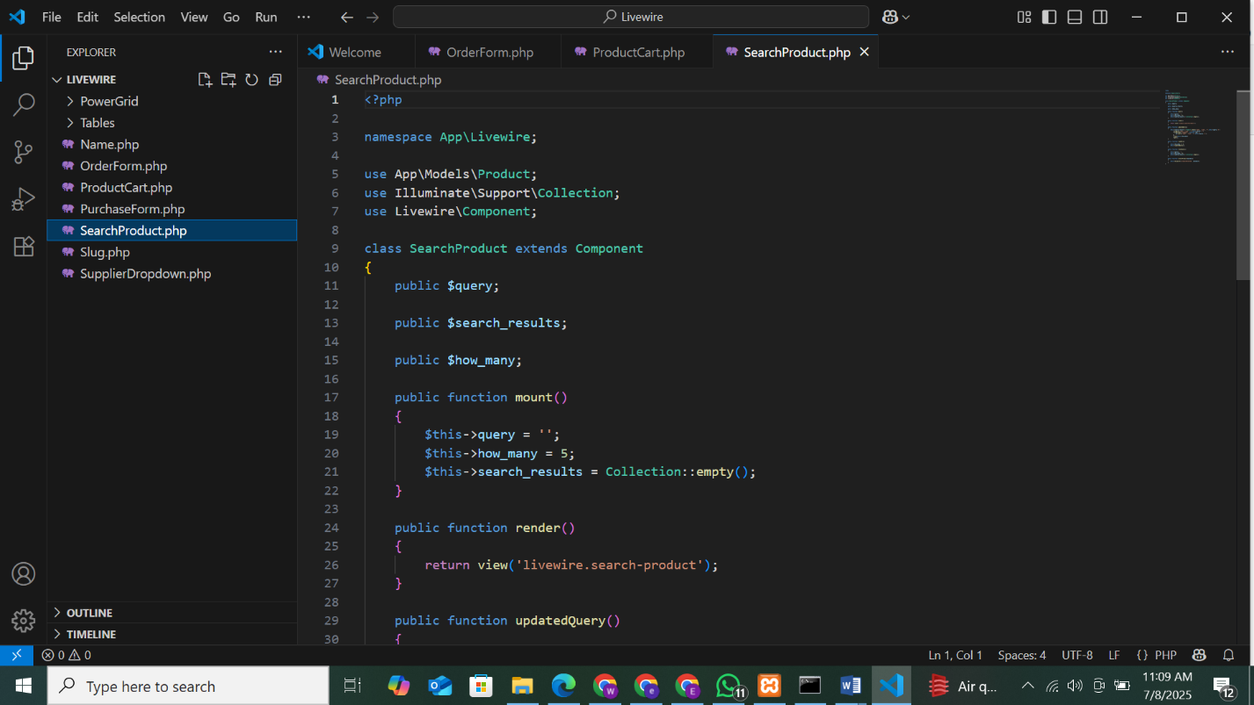

**Cloud MySQL Database Deployment**

Steps:

1. **Sign in to Aiven.io** and create a new **MySQL** service.
2. After successful creation, the following database credentials were provided:

DB_CONNECTION=mysql

DB_HOST=127.0.0.1

DB_PORT=3306

DB_DATABASE=inventory-management-system

DB_USERNAME=root

DB_PASSWORD=

1. These values should be added to Laravel’s .env file to connect the application to the cloud MySQL database.

**MySQL Database**

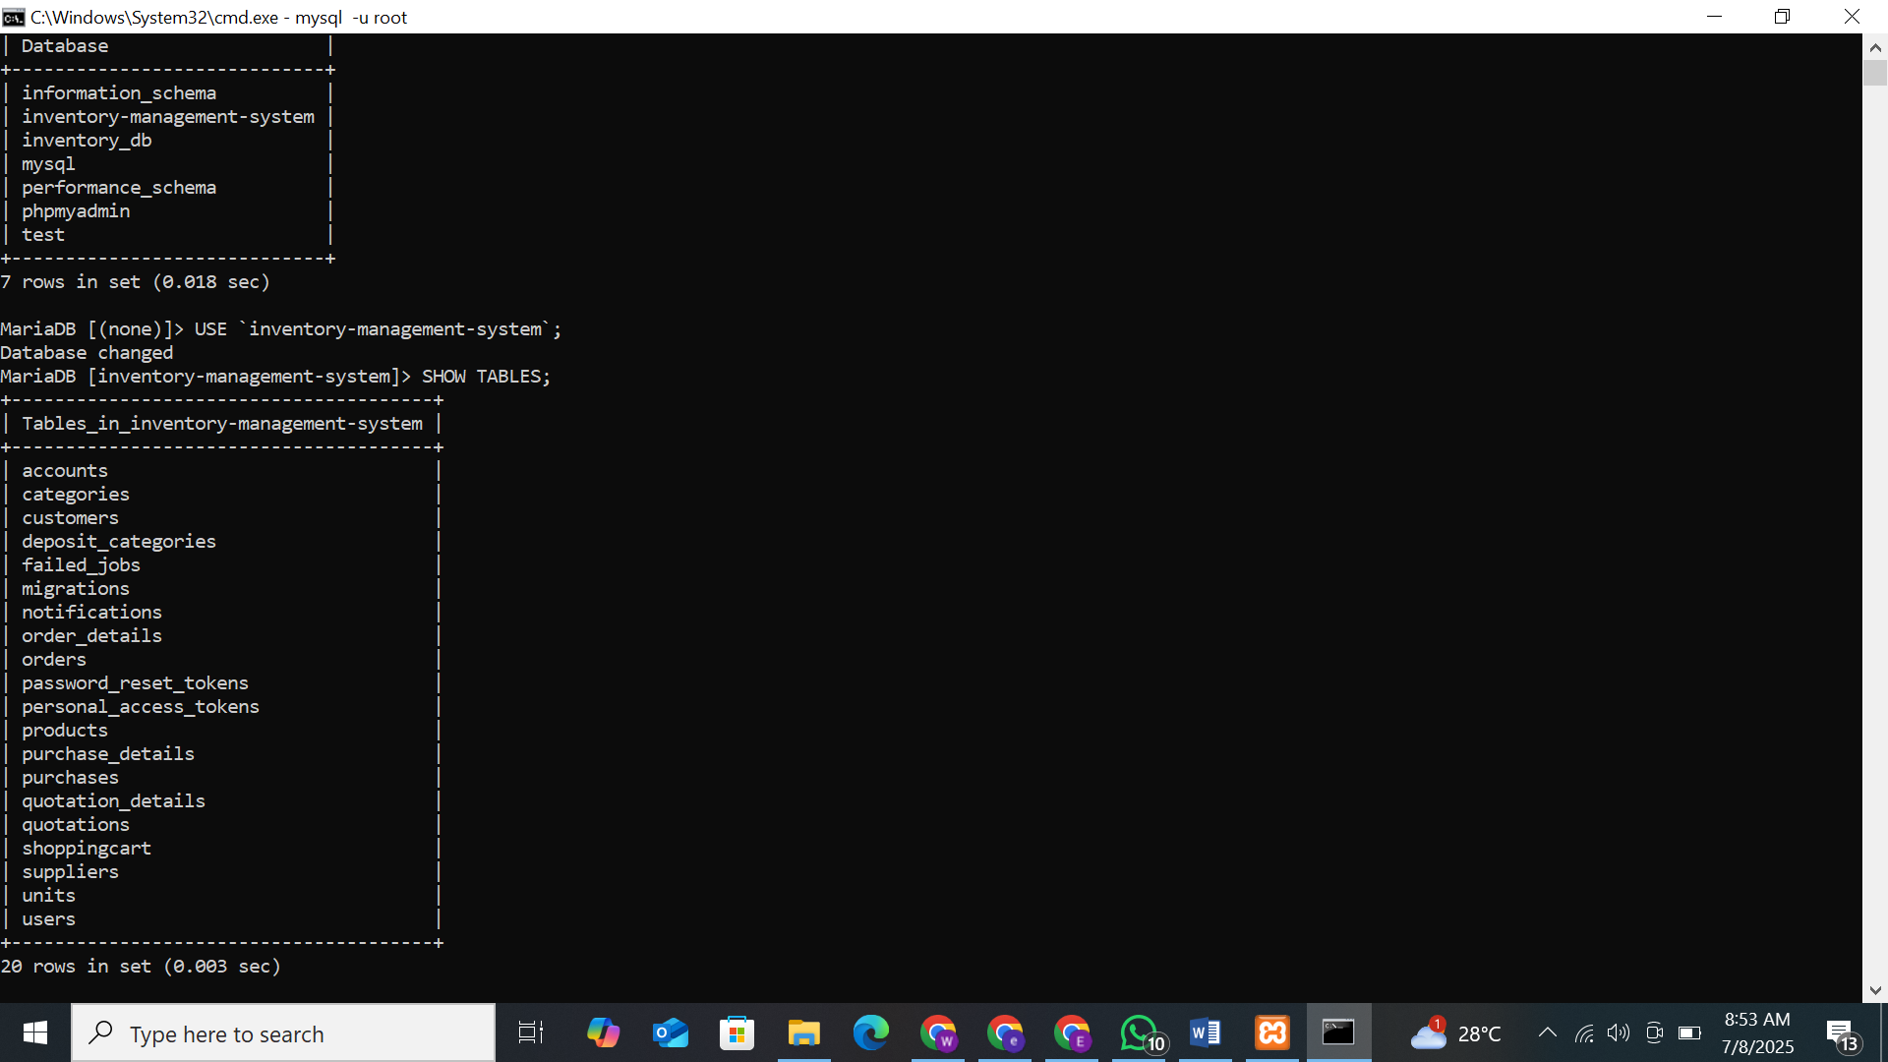

**localhost/phpmyadmin**

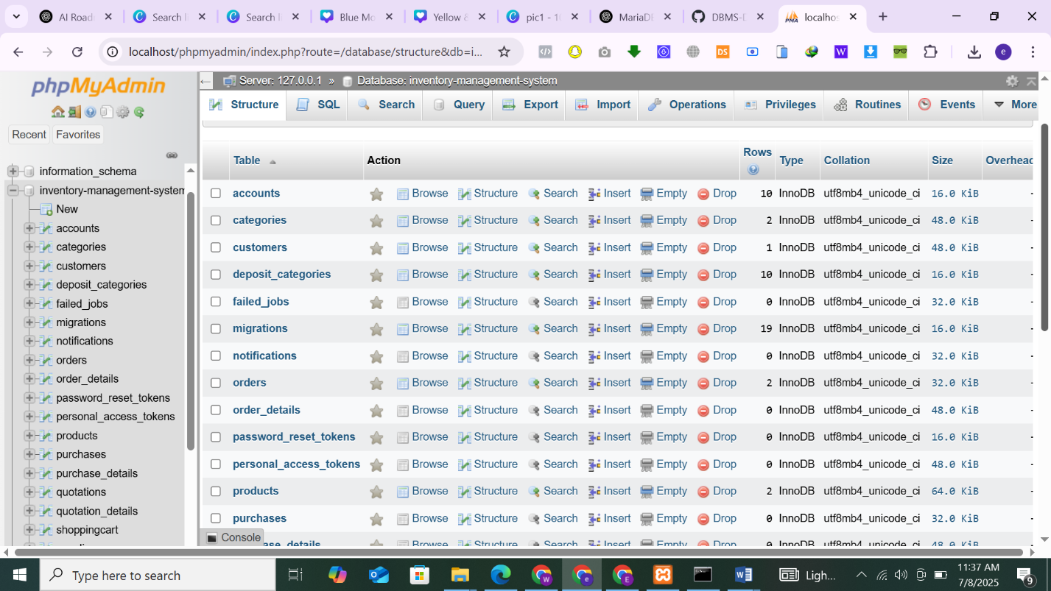

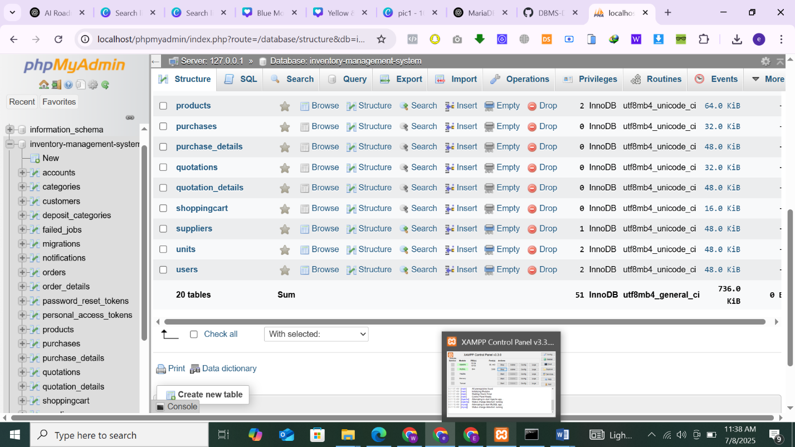

**Deployment:**

**1. Upload Project to FileZilla**

Instead of GitHub, the Laravel project was uploaded using **FileZilla** — a file hosting platform that supports direct file uploads.

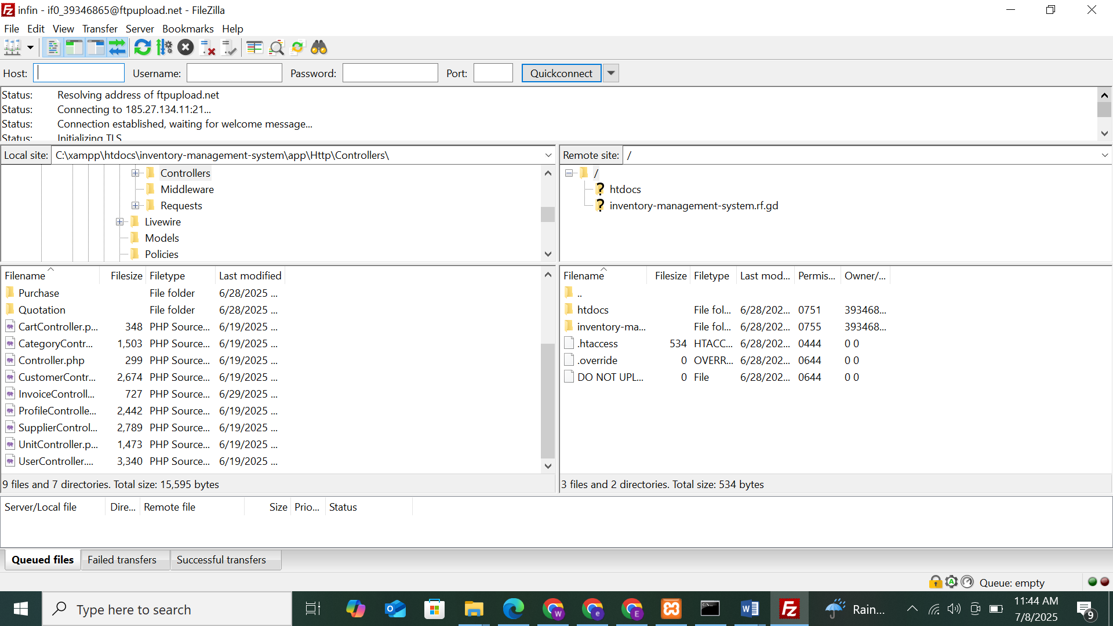

**2. Deploy to InfinityFree**

* Create a free hosting account on [InfinityFree.net](https://infinityfree.net).
* Upload the extracted public/ folder contents into the /htdocs directory via File Manager or FTP (e.g., FileZilla).
* Ensure the main Laravel index.php and .htaccess are inside /htdocs

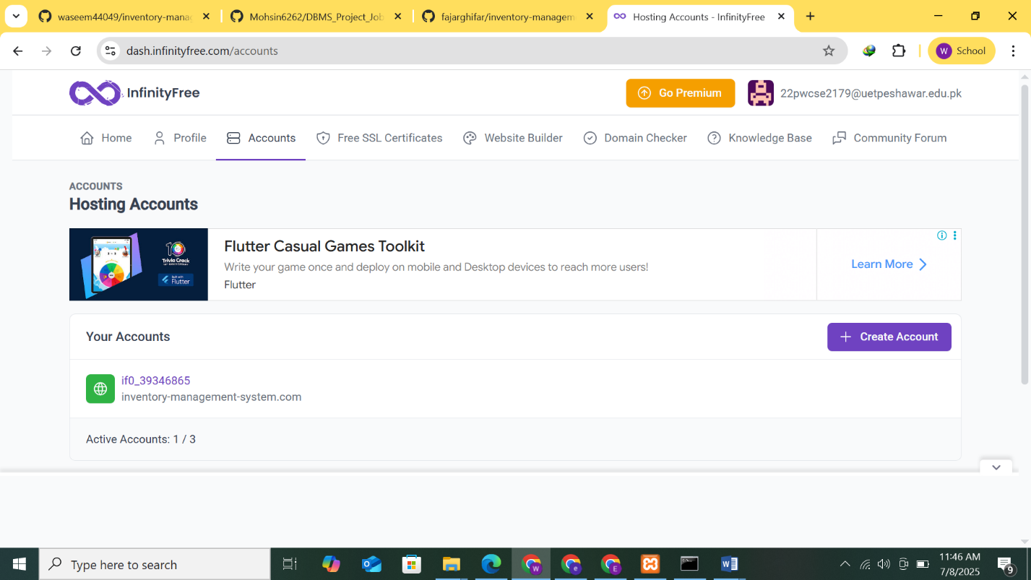

**3. Configure .env File**

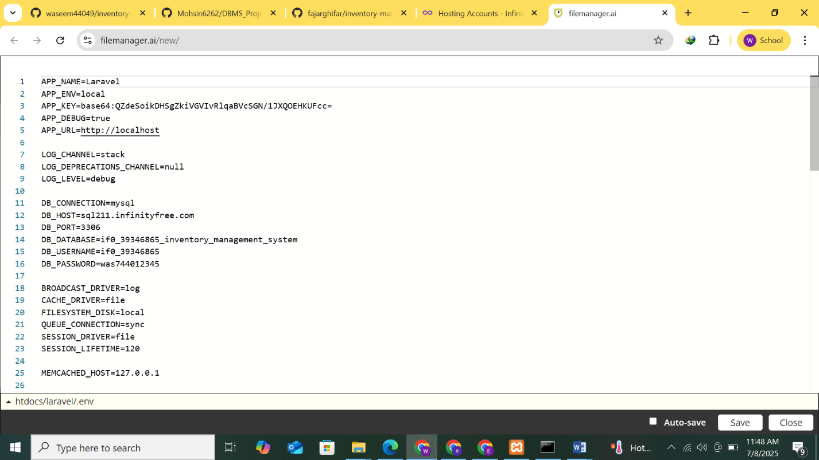Update the database credentials in your .env file using Aiven.io’s MySQL service:

**Dashboard**

**Products 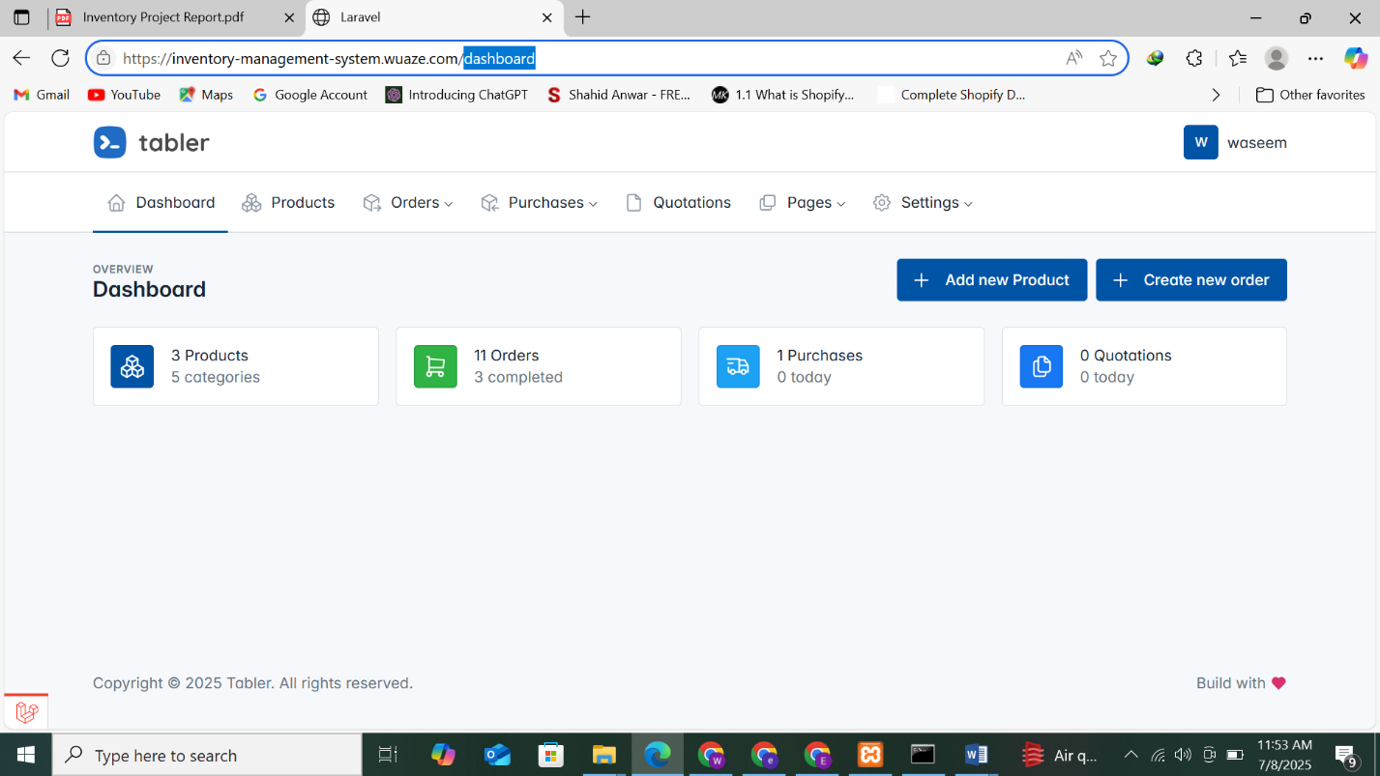Page**

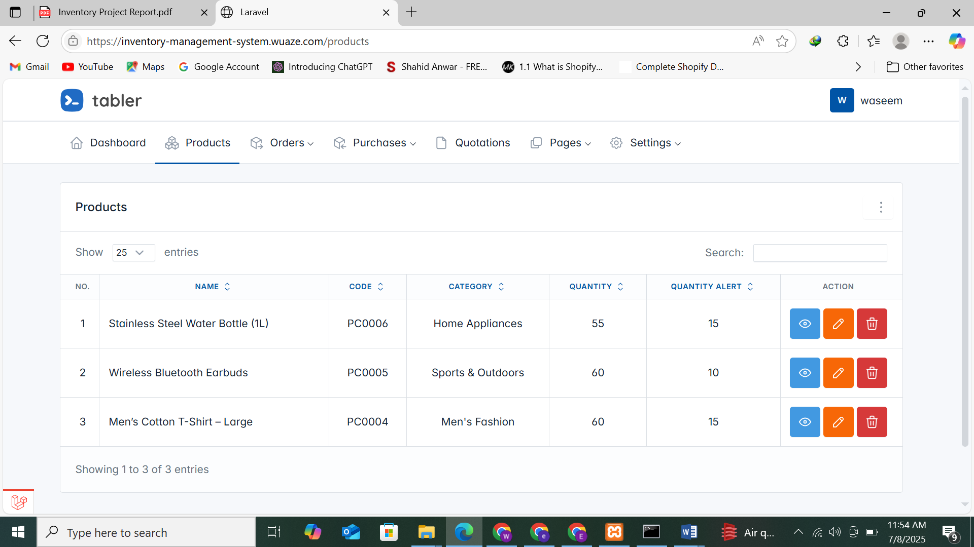

**Orders Page**

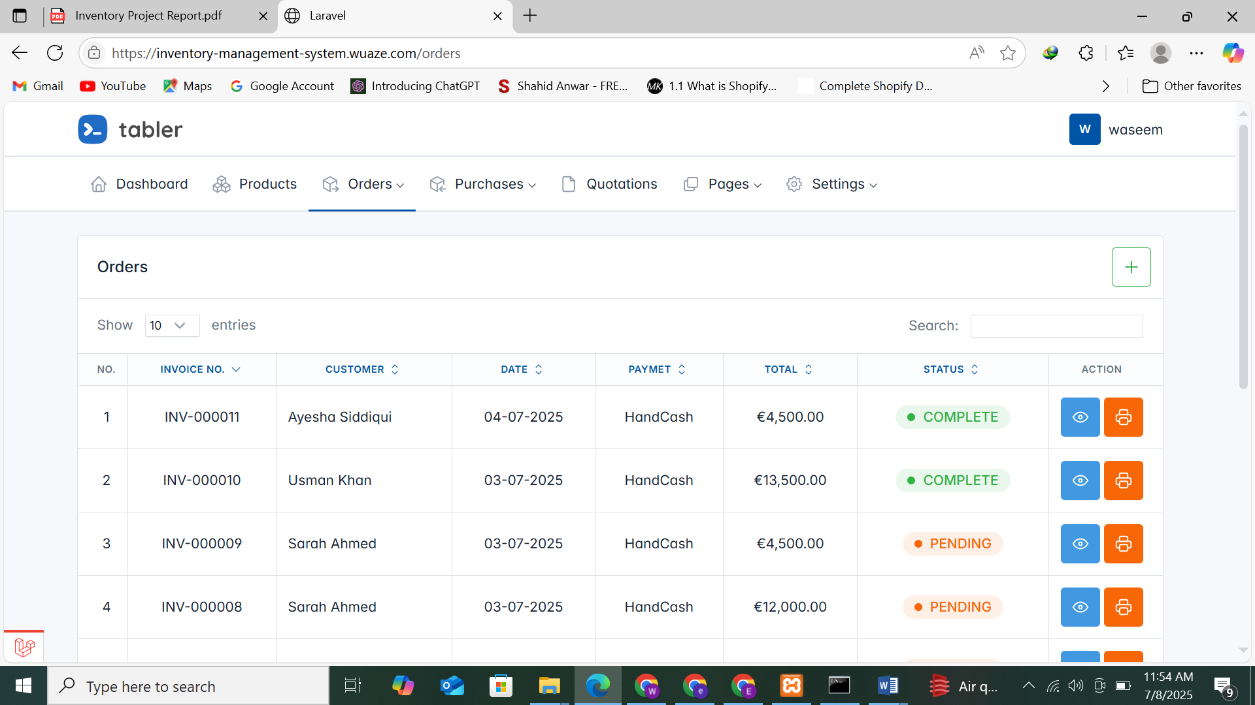

**Purchases Page**

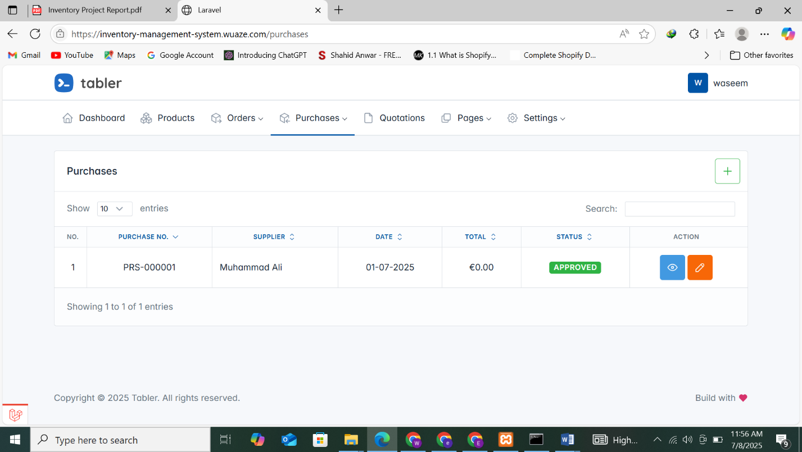

**Suppliers**

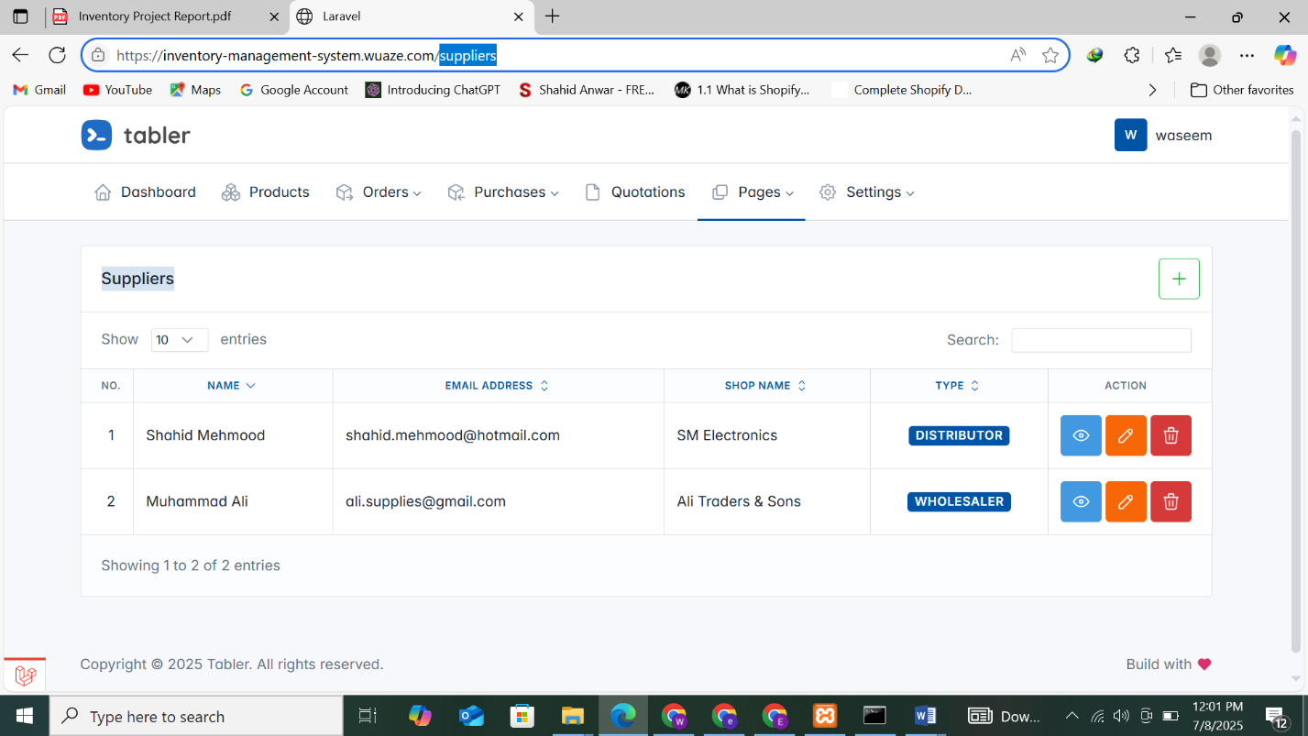

**Customers**

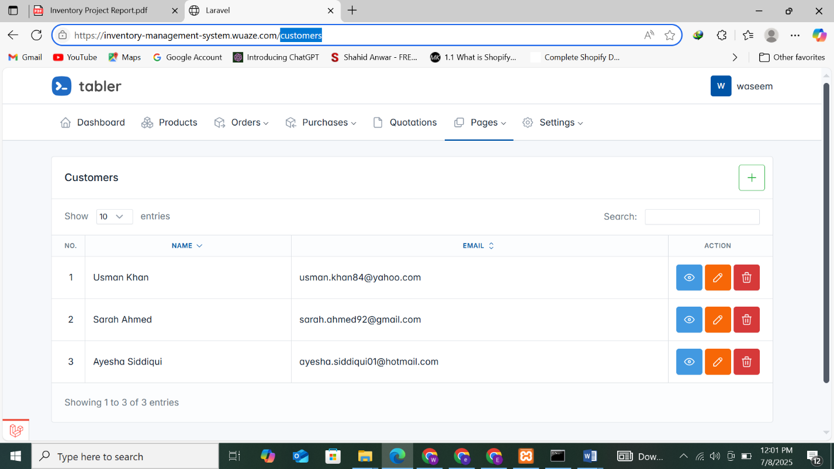

**Categories**

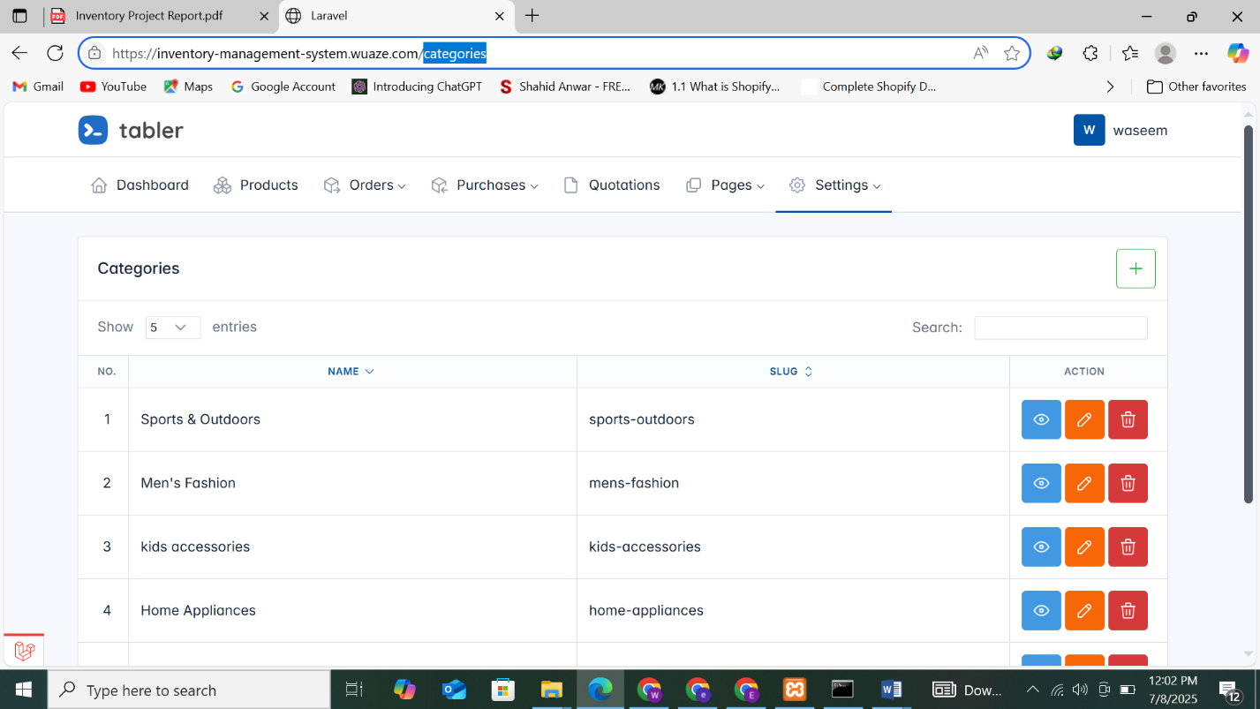

**Units**



**4. Import the Database**

* Go to **phpMyAdmin** in InfinityFree control panel.
* Create a new database (e.g., [inventory-management-system](https://github.com/waseem44049/inventory-management-system)).
* Import your .sql file using the Import tab.

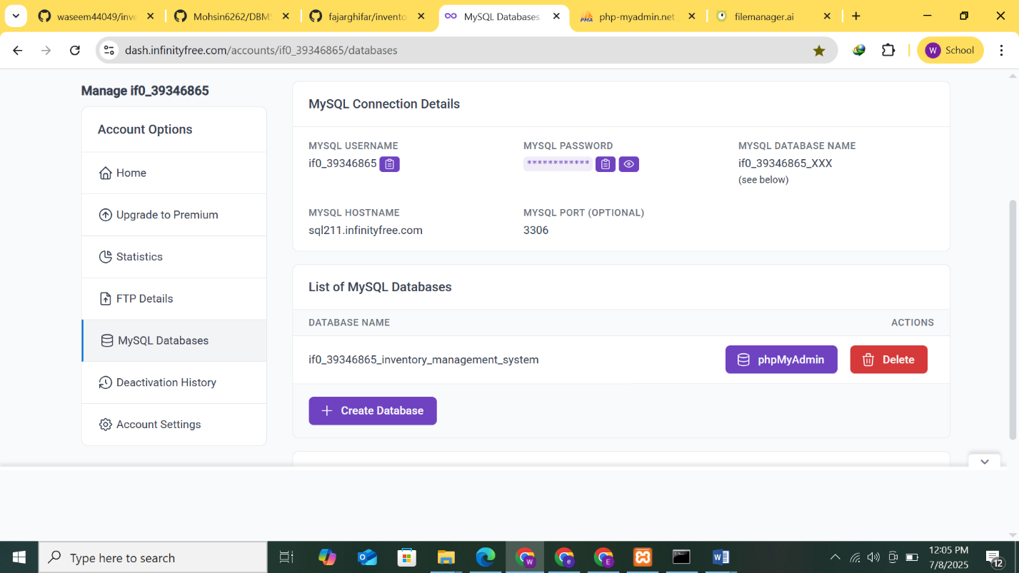**MySQL Connection Details**

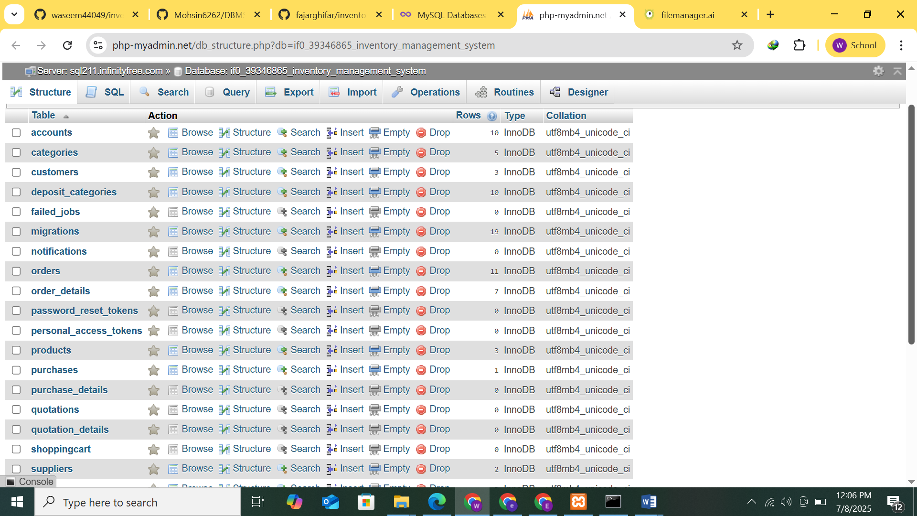

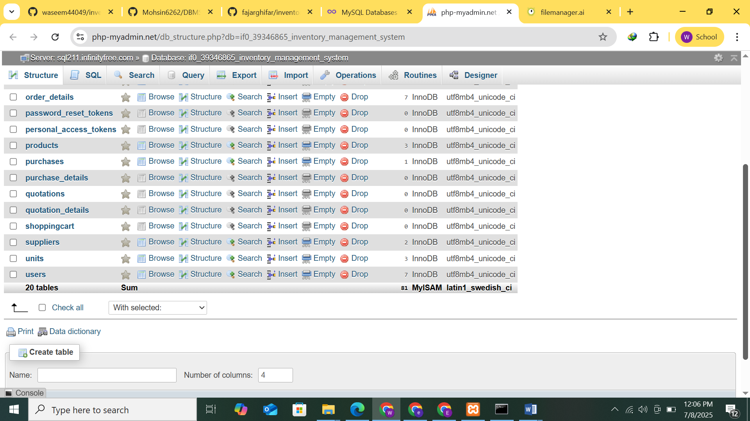**Products**

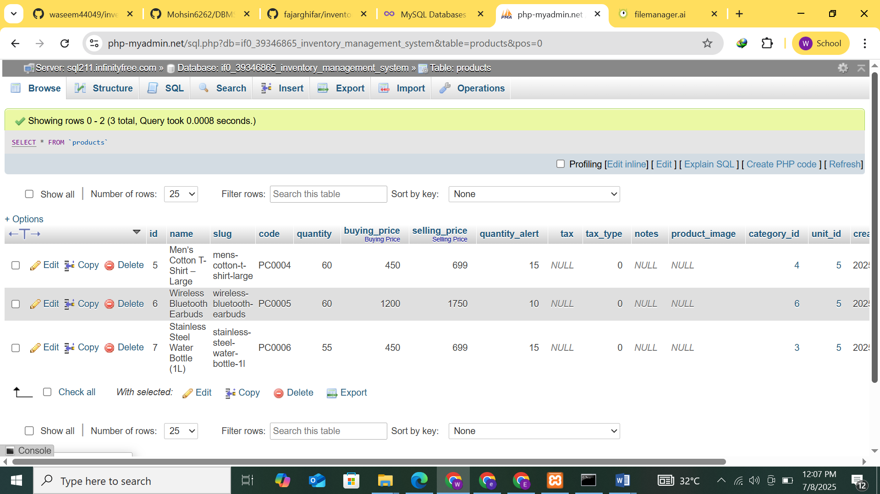

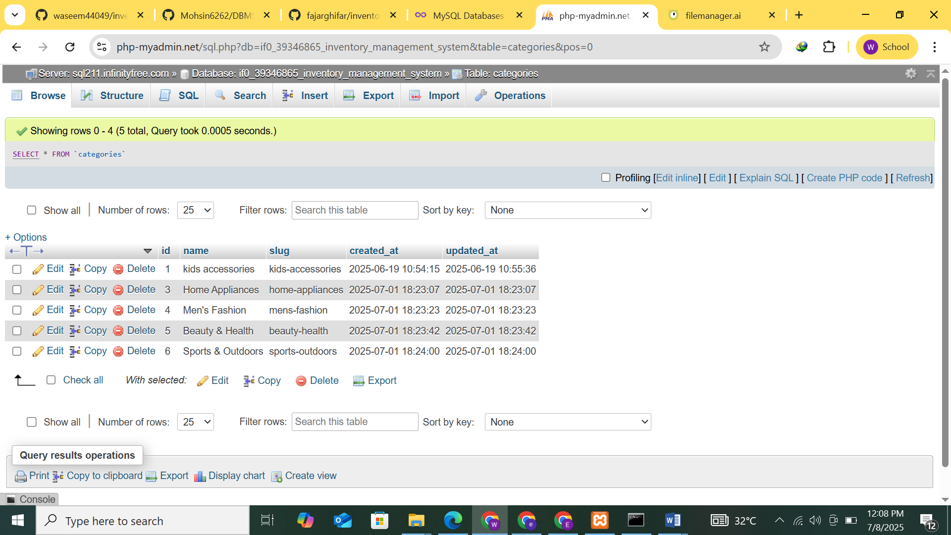**Categories**

**Purchases**

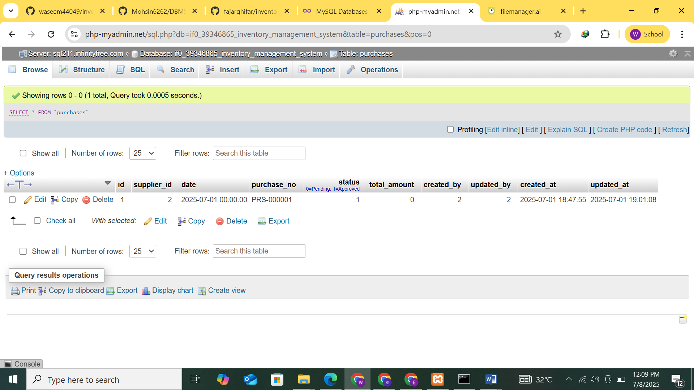

**Units**

**Deployment Links:**

[purchases](https://php-myadmin.net/sql.php?db=if0_39346865_inventory_management_system&table=purchases)

**Website Link:** <https://inventory-management-system.wuaze.com/dashboard>

**MySQL Database**: https://php-myadmin.net/db_structure.php?db=if0_39346865_inventory_management_system

**Admin Panel:** https://dash.infinityfree.com/accounts/if0_39346865

**Admin Credentials:** Username if0_39346865 | Password was744012345

**Github.com**

https://github.com/waseem44049/inventory-management-system

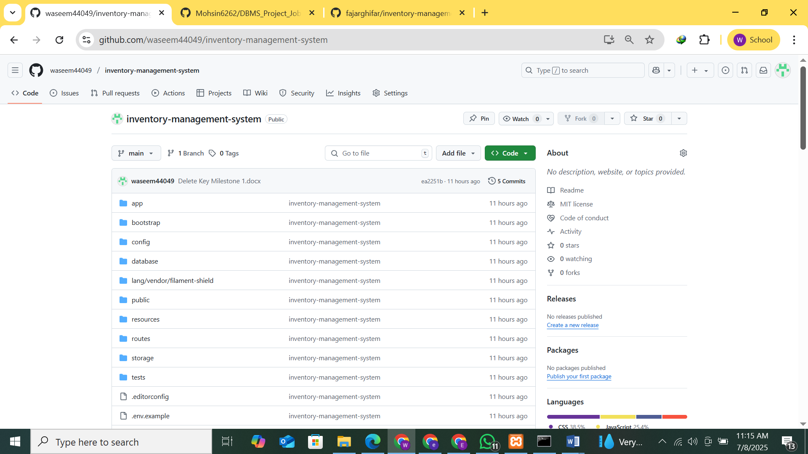

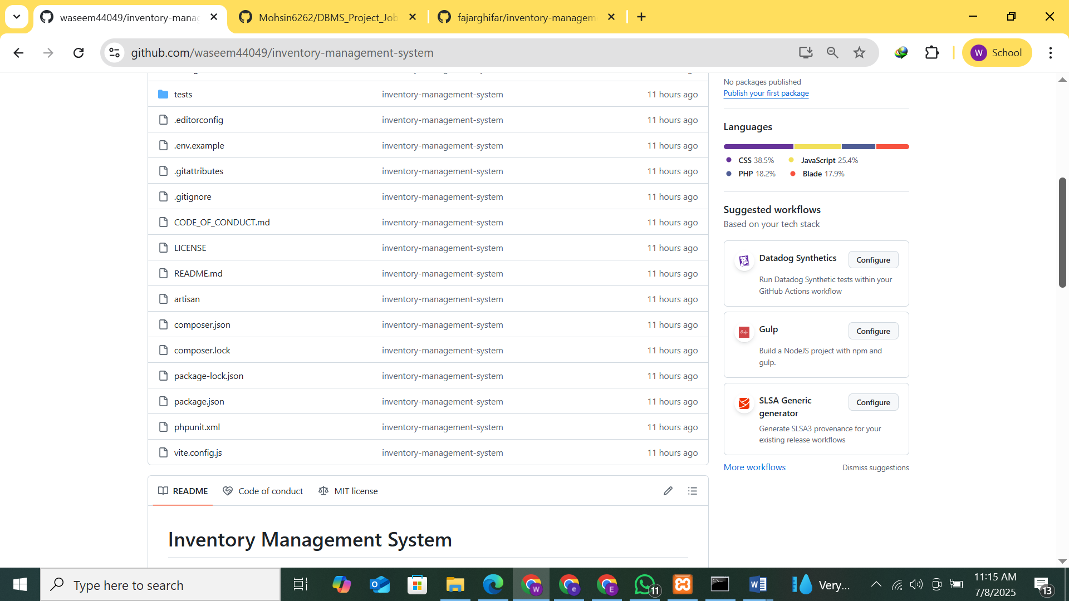

**Conclusion**

The Inventory Management System was successfully designed and implemented using Laravel 12 and MySQL. It streamlines key business operations such as product management, purchases, sales, and reporting. By using modern web technologies and best practices, the system provides an efficient, user-friendly, and scalable solution for small to medium-sized businesses.

Deployment on **InfinityFree** with a cloud-hosted MySQL database demonstrates the system’s flexibility for real-world usage. Overall, this project improves inventory visibility, reduces manual effort, and ensures data accuracy — helping businesses manage their stock and orders effectively.

## REFERENCES:

* GITHUB:  <https://github.com/fajarghifar/inventory-management-system>
* YOUTUBE: <https://www.youtube.com/watch?v=jk8L4_Wx40U>
* DEEPSEEK: <https://chat.deepseek.com/a/chat/s/a015c34d-5878-4c89-9cb1-ecd7c1ff4e56>
* Chatgpt:  https://chatgpt.com/c/686caf0d-040c-8003-a9fc-7925c299c3fc